## Merchant

Scoping start date: Nov 6, 2023

Implementation Completed Date (Go live date): Feb 15, 2024

MSA Signature Date: Mar 25, 2024

GTM POC: Jarrett

ERP: QBO

Tax Integration: No Tax

### 

### Key people at Merchant

### CEO: [Dexter Dethmers](mailto:dexter@hienergyagency.com) dexter@hienergyagency.com

* Cofounder- AR Lead: Jen Goodwin <jen@hienergyagency.com>

### Company summary

Hi Energy is an affiliate marketing agency

AM Notes

Friends of Ali.

Their contract includes a referral clause: For any client referred by Hi Energy Agency who becomes a Tabs customer, Tabs will apply 10% of closed revenue to HiEnergy's software costs.

We also committed to helping them strengthen their contract language and terms

### Billing model

* Info on how merchant bills: Flat Saas, may include usage soon
* How contract is broken up
* One off things to know about merchant

### Contract Processing Steps

1. Steps to process or specifics processing things merchant has requested that may differ from contract (e.g. always back-date invoice date to final day of the month)

4/25 update: Please use effective date if listed, if not use service date, if neither please use signature date. If no other date are on construct, please use date contract was uploaded in garage

Effective Date - Use date uploaded unless otherwise stated on contract  
Service Terms - Default to 6 months   
Default to Net 0 Payment Terms

**8/20/25 update:**  
If an invoice contains the following clause about month-to-month: 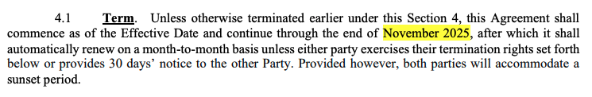

Create 12 monthly invoices *in addition* to the regular first invoice. The monthly amount will be stated in the contract.

### Events Processing (if necessary)

* Any important information on events billing

### Customer Information

* Any important information on specifics customers of this merchant
  + Special memo’s certain invoices require
  + Invoice changes due to merchant/customer relationship

### Feature Requests

* FR 1
  + What is it
  + Why it's important
  + Urgency

### Rewatch Calls

* Rewatch by dates
* March 22 <https://tabs.rewatch.com/video/rtlo8ik39rvhwwzn-ali-dexter-hienergy-tabs-demo-march-22-2024>
* March 7 https://tabs.rewatch.com/video/rtlo8ik39rvhwwzn-ali-dexter-hienergy-tabs-demo-march-22-2024